IMAGE AND VIDEO PROCESSING
4. Image Transforms
4.1 Introduction to Unitary Transforms.
4.2 Discrete Fourier Transform (DFT), Inverse DFT, Properties of DFT, Fast Fourier Transform (FFT).
4.3 Discrete Hadamard Transform (DHT), Inverse DHT, Fast Hadamard Transform (FHT), Discrete Cosine Transform (DCT), Inverse DCT
PAST QUESTIONS:
- Write an expression for a two-dimensional DCT. Form a 4x4 DCT matrix and compute the DCT of the following sub-image.
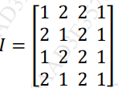
- What is meant by Unitary transform.
- What is Image Transform? What is the significance of Image Transform? Write basis images of Walsh Hadamard Transform.
- Explain in detail DFT and Inverse DFT.
- Short note on Hadamard Transform.
- Compare DFT and FFT
- Numerical on DFT.
- Short note on Fast Hadamard.
NOTES:

*Unitary Transform :-
Unitary transforms are mathematical operations used in image processing and signal processing to convert data from one domain to another, usually for compression, enhancement, or analysis.
A unitary transform is a linear transformation that preserves the energy (norm) of the signal. Mathematically, a transform U is unitary if:
U*U = UU* = I
Properties –
- Energy preservation: No loss of information
- Orthogonality: Basis vectors are orthogonal (independent)
- Invertibility: Easy to reverse the transform
Common Unitary transforms are: DCT, FT, Hadamard transform.
Application in Image processing –
- Image compression
- Image enhancement
- Noise reduction
- Feature extraction

*DFT :-
The Discrete Fourier Transform (DFT) is a technique used to convert an image from the spatial domain (intensity values at pixels) to the frequency domain (representation of how image content varies spatially).
- The spatial domain shows what the image looks like.
- The frequency domain shows how fast the pixel values are changing in different directions.
Transforming an image to the frequency domain allows us to:
- Analyze image content in terms of frequencies.
- Apply filters (e.g., low-pass, high-pass) more effectively.
- Compress images by removing less important frequencies.
- Enhance images by focusing on specific frequency components.
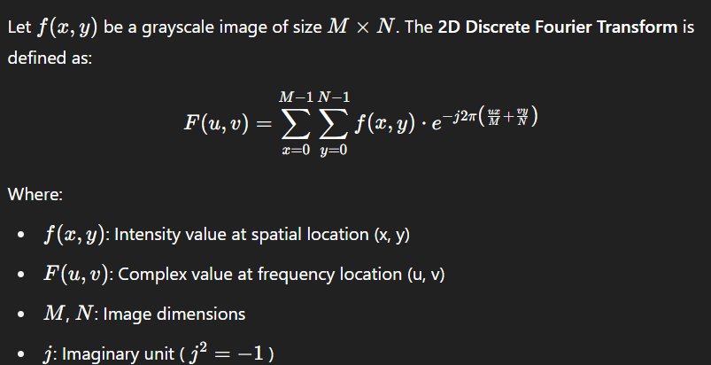
Applications –
Image Filtering:
- Low-pass filter: Removes high frequencies (blurring)
- High-pass filter: Removes low frequencies (sharpening)
Image Compression:
- Remove less significant frequencies to reduce file size.
Image Enhancement:
- Amplify certain frequencies to enhance features.
Pattern Recognition:
- Compare images in frequency domain for better invariance.

*I-DFT :-
The Inverse Discrete Fourier Transform (IDFT) is the mathematical operation that transforms a signal or image from the frequency domain back into the spatial domain.
In image processing:
- DFT is used to analyze and manipulate the image in the frequency domain.
- IDFT is used to reconstruct the original image after processing.
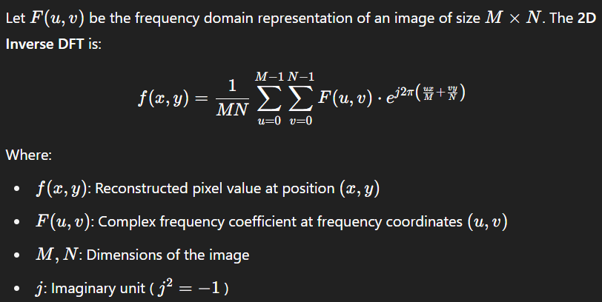

*DFT vs FFT :-
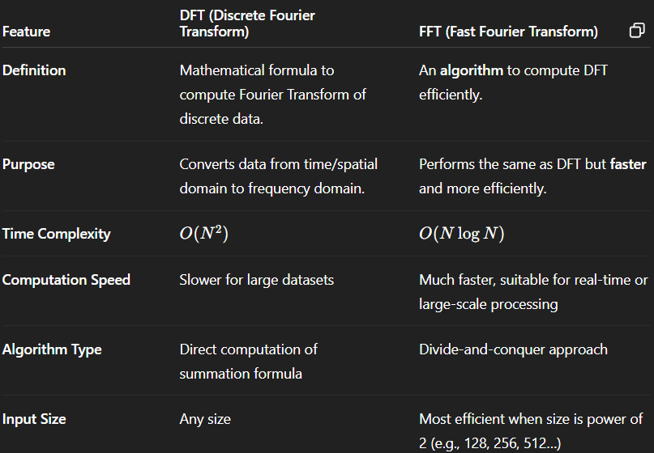
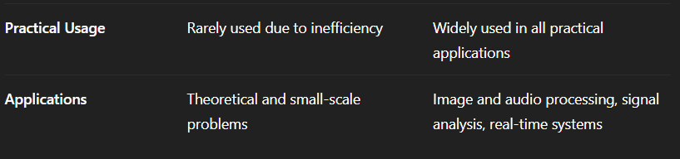

*Hadamard Transform :-
The Hadamard Transform is a non-sinusoidal, orthogonal transform widely used in signal and image processing for its simplicity and speed.
It transforms a signal or image from the spatial domain into a domain represented by square waveforms instead of sine and cosine waves.
Uses Hadamard matrices composed only of +1 and -1 values.
It is a unitary and orthogonal transform, meaning it preserves energy and is invertible.
Applications –
- Image compression and feature extraction.
- Error correction codes in communication.
- Pattern recognition and fast signal analysis.
- Data encryption and multiplexing.

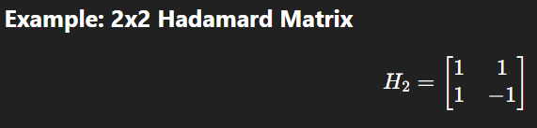

*Walsh Hadamard transform :-
Image Transform refers to a mathematical operation that converts an image from the spatial domain (pixels) to another domain, typically the frequency domain. This transformation makes it easier to analyze, process, compress, or enhance the image.
Significance of Image Transform:
  - Image Compression: Transforms concentrate image energy in fewer coefficients, helping in efficient image storage (e.g., JPEG uses DCT).
  - Image Enhancement: Filtering in the transform domain can enhance or sharpen features.
  - Noise Reduction: Noise can be isolated and removed in the transform domain.
  - Feature Extraction: Transforms help detect patterns, textures, or edges in images.
  - Efficient Computation: Many operations like convolution become simple multiplications in the frequency domain.
Walsh-Hadamard Transform (WHT):
- WHT is an orthogonal, non-sinusoidal transform using only +1 and -1 values.
- It is based on Hadamard matrices and uses square wave basis functions.
- It is a unitary transform, useful for fast computation and applications like compression and pattern recognition.

